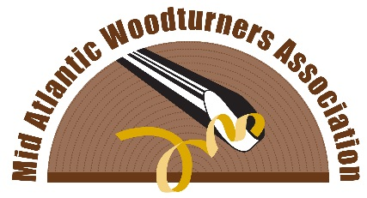
Volunteer Information
Mid Atlantic Symposium
September 24-25, 2016
Lancaster, PA www.mawts.com

This form is intended to gather information from those who are interested in volunteering their time and energy in support of the 2016 symposium. Some tasks will be needed in advance and following the event and some at the time of the event, and these volunteer efforts are essential to the success of the symposium. There will be a need for approximately 75 volunteers in various areas, and we will do our best to match your interest with the need. Thank you for volunteering.
Name________________________________________________________________________________
Address______________________________________________________________________________
City______________________ State_________ Zip_________
Phone (H) (W) (Cell) ____________________________________________________________________
Email (please print neatly) _______________________________________________________________
Club affiliation- Please list all AAW chapters you belong to: _____________________________________
Indicate areas for which you wish to volunteer:
___ Registration desk/ greeting ___ Demo Room monitor / assistant ___ Instant Gallery monitor
___ Video Equipment operator * Note- this will require some advance training and a specific time commitment. Prior experience is desirable.
___ Demonstrator hosting (Transportation to and from airport) – Friday, Sunday, possibly Monday
___ Equipment pick up and delivery- Thursday or Friday. Return after event- Sunday / Monday
___ Demo room set up- Friday
___ Assist vendors on arrival (Friday)
___ Banquet / Auction assistance
___ Other items during event days (not specified)
___ Other items in advance (not specified)

Please complete the above and submit to:
Larry Sherman, 480 New Holland Avenue, Suite 6204, Lancaster, PA 17602
Or- fax to 717-560-8885
Or- scan and email to Lsherman120@gmail.com

